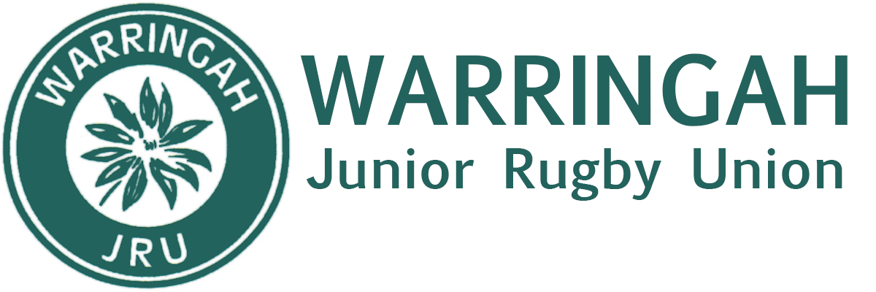

Pre-Season Development Camp 2020
RATS JUNIOR HQ - Sydney Academy of Sport, Wakehurst Parkway, Narrabeen
11am Saturday 7th – 1.30pm Sunday 8th March 2020
Cost: $150.00 per player
TEAM: Warringah U16 Representative Squad
Included:
* All meals and accommodation.
* Pillows and Doonas provided.
* Specialised skills sessions with Waratahs Gen Blue coaches and pathway manager
* Team Building activities.
* Tomorrow Man Sporting Workshop (Breaking male stereotypes and resilience workshop)
* Sports visualisation and mental performance session
* Advanced agility training with Ben Bidencope.
* Skills pathway to Colts Session with Losi Tagickibau (Coaching Director – Colts)
* Pool, Hot/Cold recovery sessions

Complete online registration by no later than Saturday 15th February 2020
https://sportandrecreation.nsw.gov.au/facilities/medicalandconsentform
Booking Number: 568896
Start Date: 7/03/2020
Booking venue: Sydney Academy of Sport and Recreation
Organisation: Warringah Junior Rugby

Full Payment via EFT no later than 29th February 2020
Westpac
Warringah JRU
BSB 032 191
Acct# 176 274
Please include players surname & team when making payment. E.G Smith U16s

Bring:
- Toiletries.
- Casual clothes and everything required for training including mouthguard, boots and headgear.
- Hat, sunscreen and water bottle.
- Bring linen. Suggest sleeping bag and pillowslip or sheets (if you think your son will make his bed).
- Swimming gear and towel
- No Phones or Devices

Contacts:
Todd Marks
tmarks@maverick.com.au
0411 285 512

